**How to user Normaliser**

1. Transform store_sales.csv data into normalised_store_sales.csv



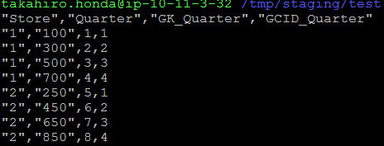

1. Under Normalised Fields, Click the arrow and choose Generate from Incoming Fields and select only Store.
2. From the arrow, click add new field. Add new field, Revenue, and add occurrence (in this case 4 columns). CGID_ (Generated Column ID) and GK_ (Generated Key) will be added automatically.

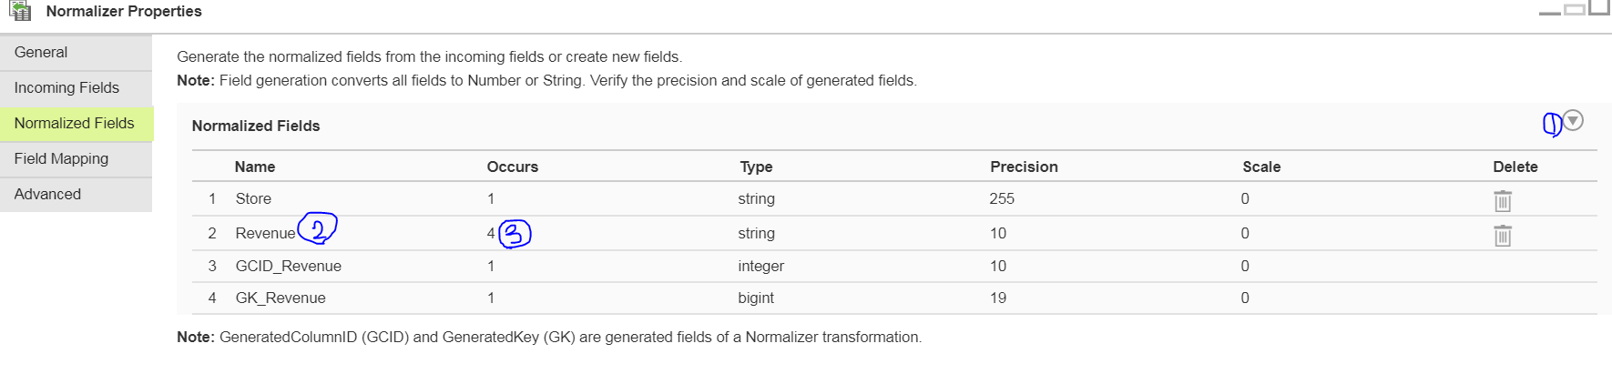

1. Once the field occurrence is defined 4 times, you will see the Revenue field repeated 4 times. Map each column into the each field as below.

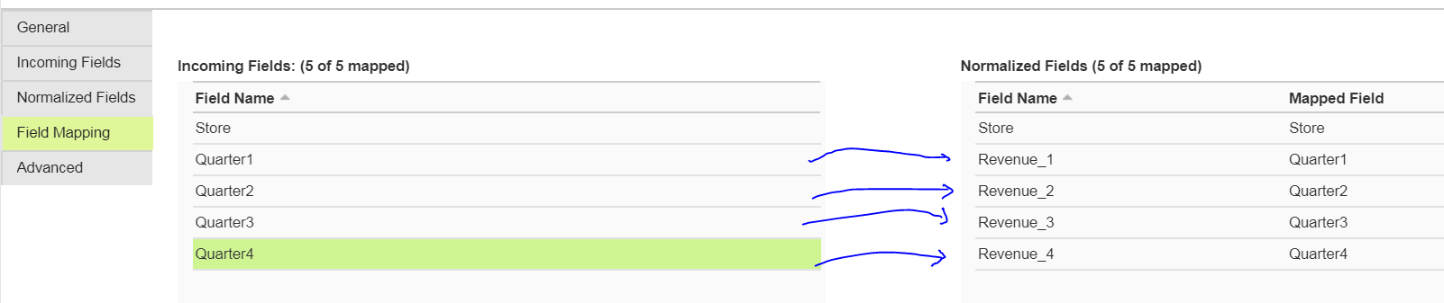

1. GCID_Quarter needs to be converted into the right column name.

1 = Quarter 1, 2 = Quarter 2, 3 = Quarter 3, 4 = Quarter 4



For this, we use expression stage

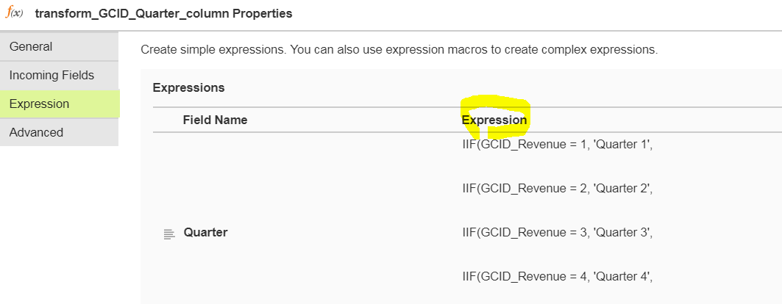

1. Final Outcome

